**Masuratori simulate :**

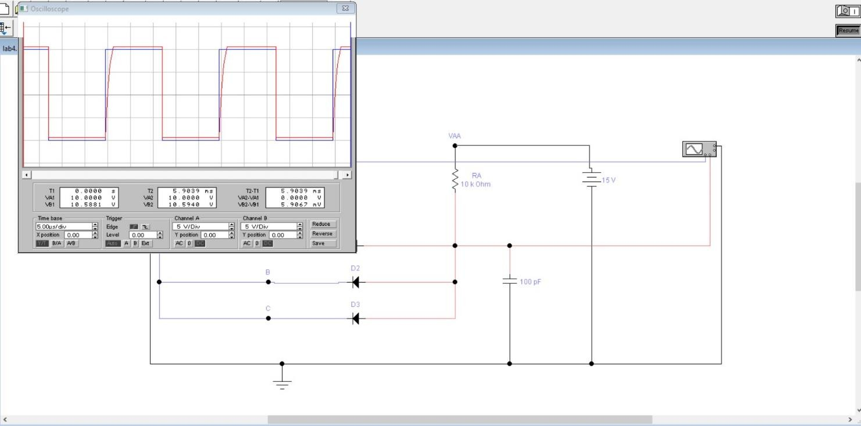1) C = 100 pF

2) C = 220 pF

3) C = 470 pF

4) C = 1 nF

5) C = 1.5 nF

